**Lab Exam**

Q1)

>

import java.io.IOException;

import org.apache.hadoop.conf.Configuration;

import org.apache.hadoop.fs.Path;

import org.apache.hadoop.io.DoubleWritable;

import org.apache.hadoop.io.LongWritable;

import org.apache.hadoop.io.Text;

import org.apache.hadoop.mapreduce.Job;

import org.apache.hadoop.mapreduce.Mapper;

import org.apache.hadoop.mapreduce.Reducer;

import org.apache.hadoop.mapreduce.lib.input.FileInputFormat;

import org.apache.hadoop.mapreduce.lib.output.FileOutputFormat;

public class AllTimeHigh

{

public static class MapClass extends Mapper<LongWritable, Text, Text, DoubleWritable>

{

public void map(LongWritable key, Text value, Context context)

{

try

{

String[] s = value.toString().split(",");

double high = Double.parseDouble(s[4]);

context.write(new Text(s[1]), new DoubleWritable(high));

}

catch (Exception e)

{

System.out.println(e.getMessage());

}

}

}

public static class ReduceClass extends Reducer<Text, DoubleWritable, Text, DoubleWritable>

{

private DoubleWritable res = new DoubleWritable();

public void reduce(Text key, Iterable<DoubleWritable> values, Context context) throws IOException, InterruptedException

{

double max = 0.0;

for(DoubleWritable val: values)

{

if(max < val.get())

{

max = val.get();

}

}

res.set(max);

context.write(key, res);

}

}

public static void main(String[] args) throws Exception

{

Configuration conf = new Configuration();

Job job = Job.getInstance(conf, "Highest Stock Value");

job.setJarByClass(AllTimeHigh.class);

job.setMapperClass(MapClass.class);

job.setReducerClass(ReduceClass.class);

job.setNumReduceTasks(1);

job.setOutputKeyClass(Text.class);

job.setOutputValueClass(DoubleWritable.class);

FileInputFormat.addInputPath(job, new Path(args[0]));

FileOutputFormat.setOutputPath(job, new Path(args[1]));

System.exit(job.waitForCompletion(true) ? 0 : 1);

}

}

hadoop jar lab_exam.jar AllTimeHigh /user/bigcdac432556/NYSE_exam.csv /user/bigcdac432556/mr_output

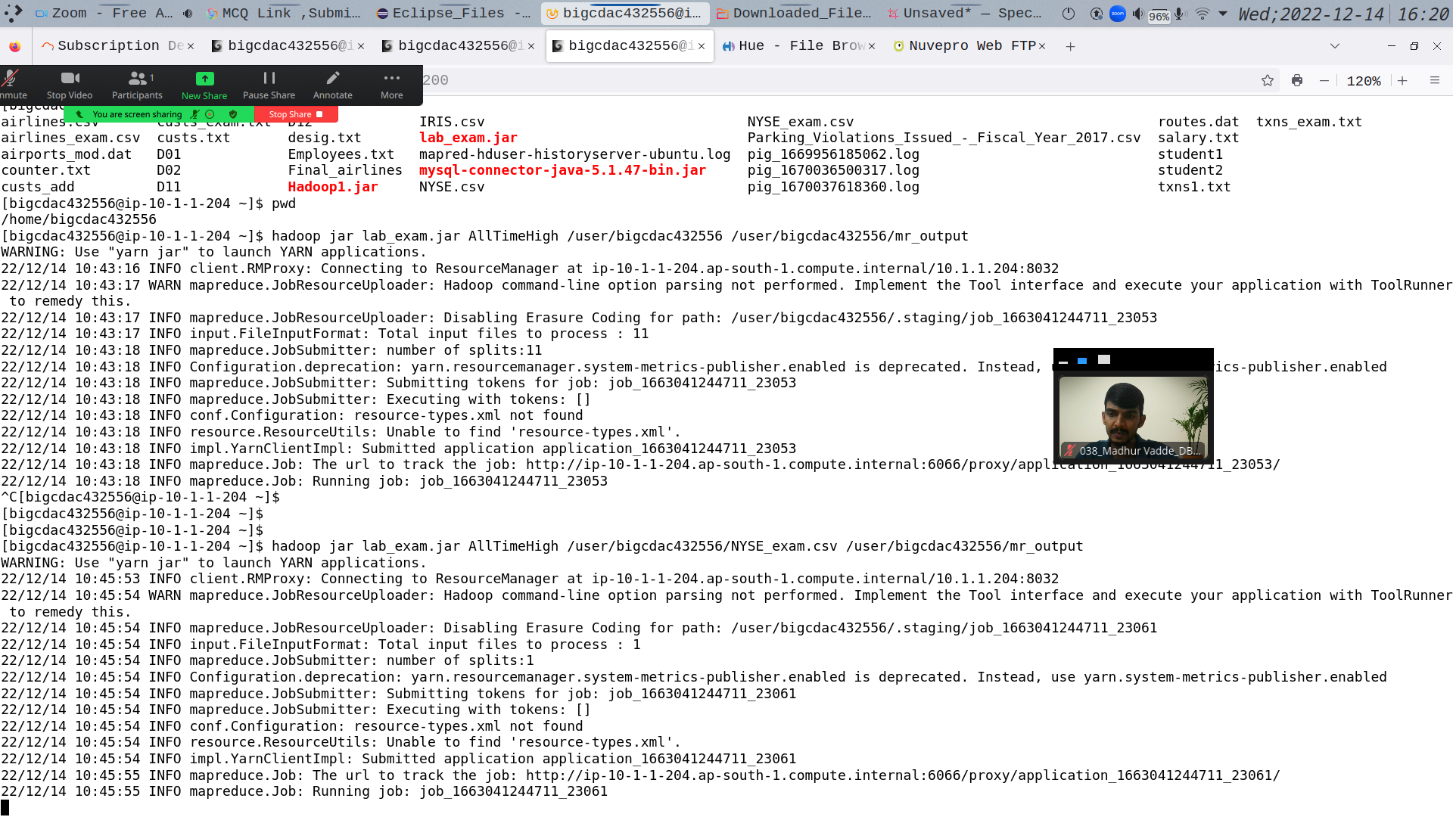

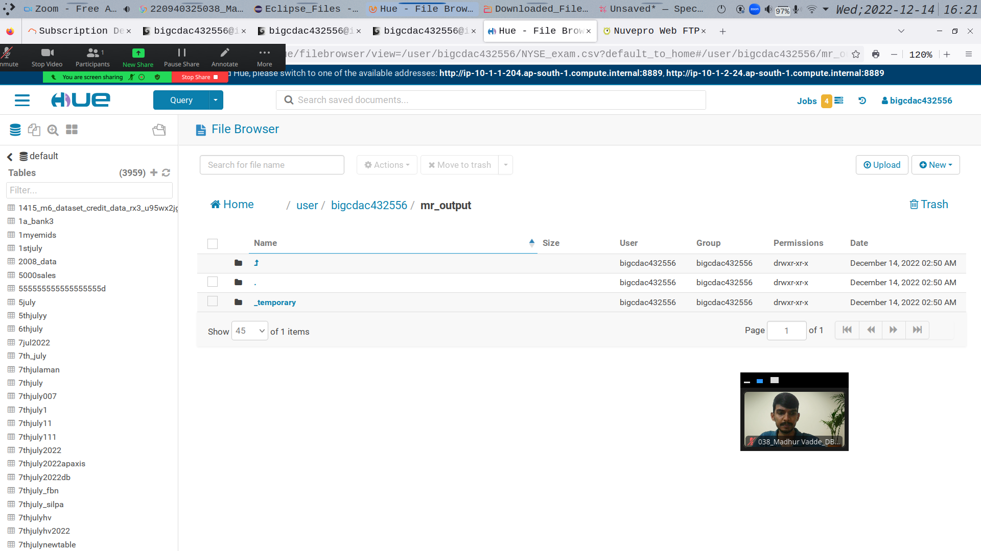

Q2)

>

Create customers table:

create table customer_exam(cust_id int, firstname string, lastname string, age int

, profession string) row format delimited fields terminated by ',' stored as textfile;

load data local inpath ‘custs_exam.txt’ overwrite into table customers_table;

**Query 1:**

select profession, count(cust_id) no_of_customers from customer_exam group by profession;

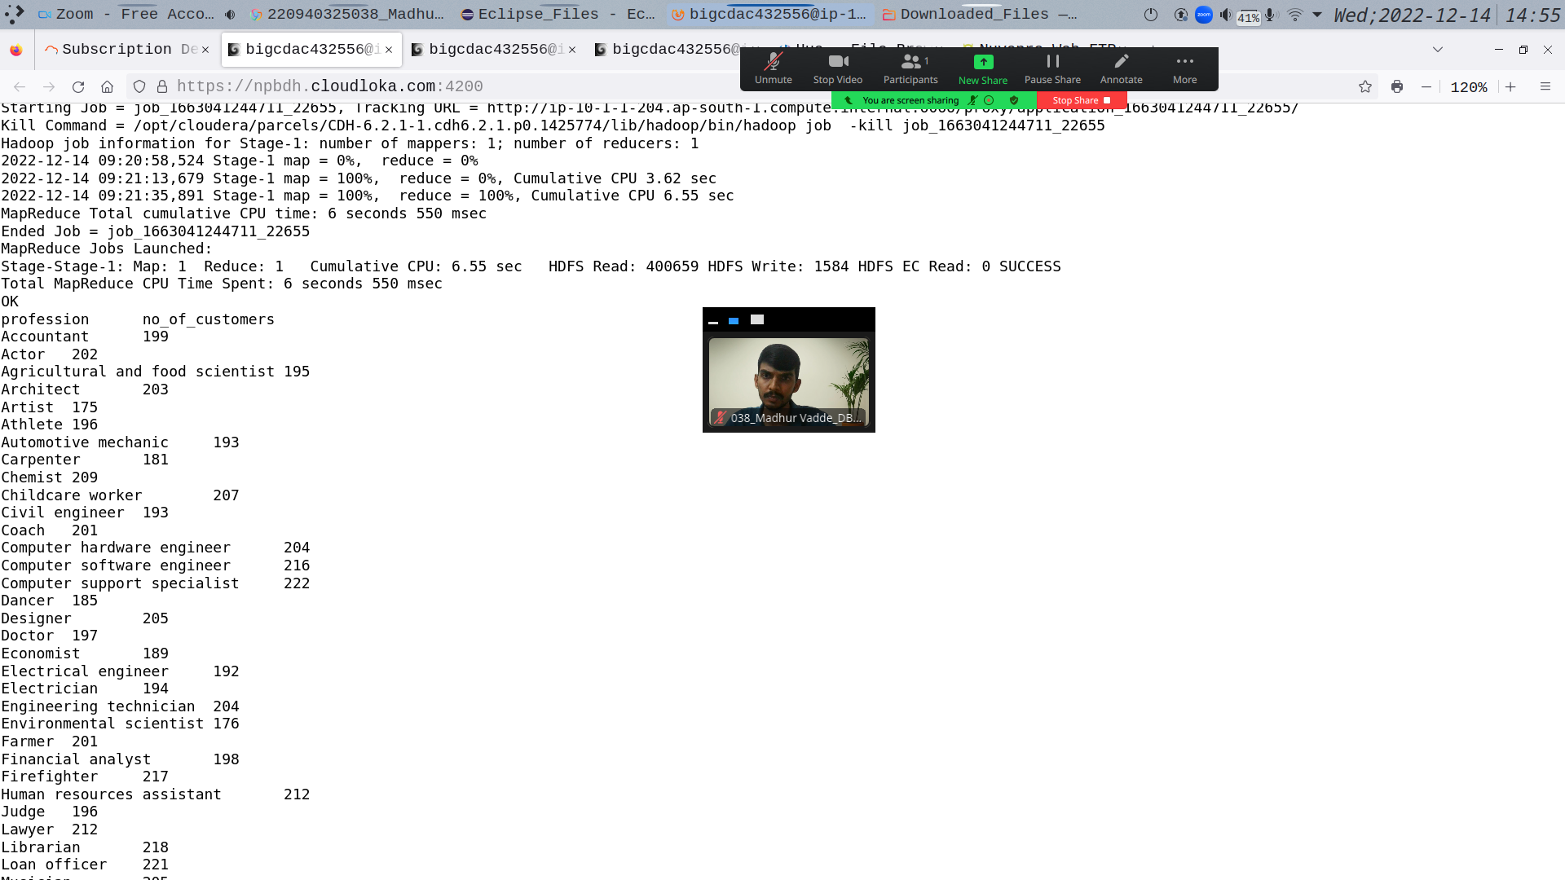

Create transactions table:

create table transactions_exam(txn_id int, txn_date string, cust_id int, amount double, category string, product string, city string, state string, spendby string) row format delimited fields terminated by ‘,’ stored as textfile

**Query 2:**

select product, sum(amount) total_sale from transactions_exam group by product order by total_sale desc limit 10;

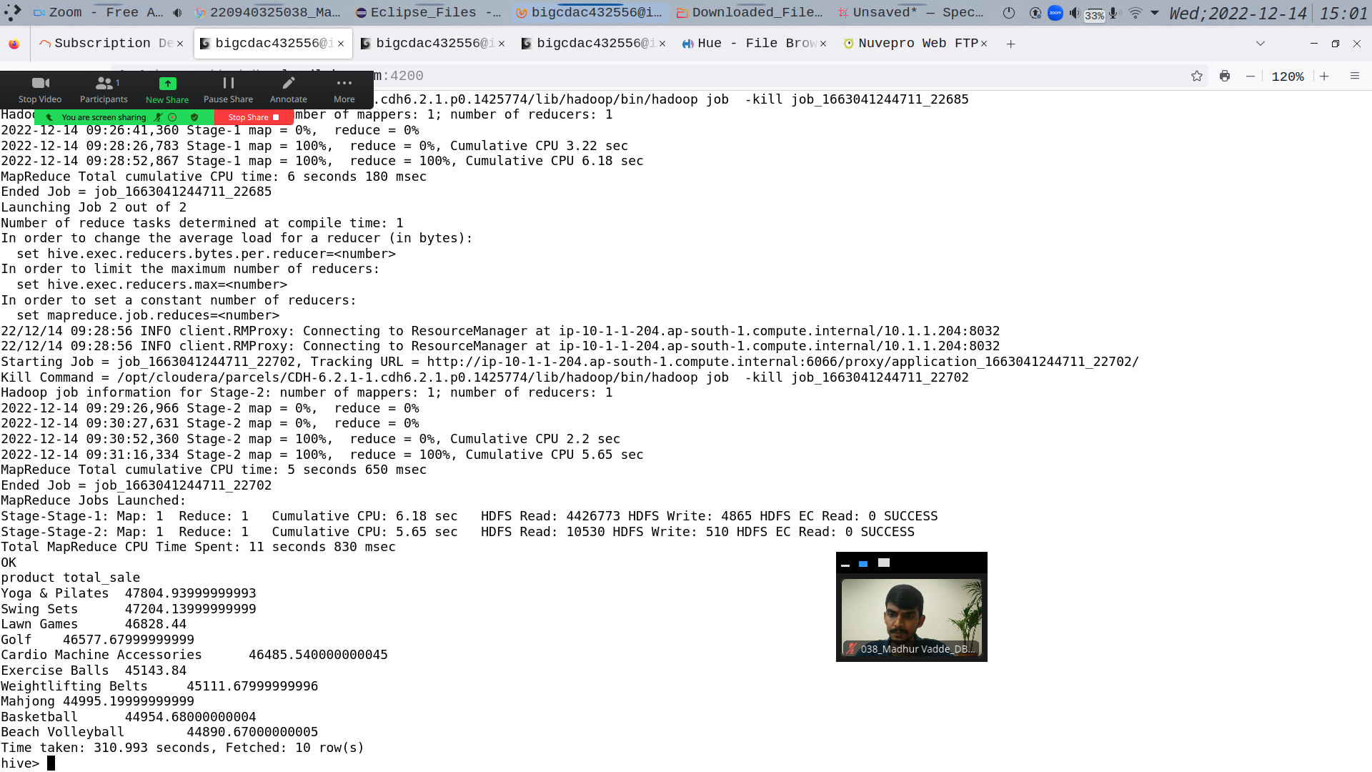

**Partitioned table on category:**

create table txn_part_exam(txn_id int, txn_date string, cust_id int, amount double, product string, city string, state string, spendby string) partitioned by (category string) row format delimited fields terminated by ‘,’ stored as textfile;

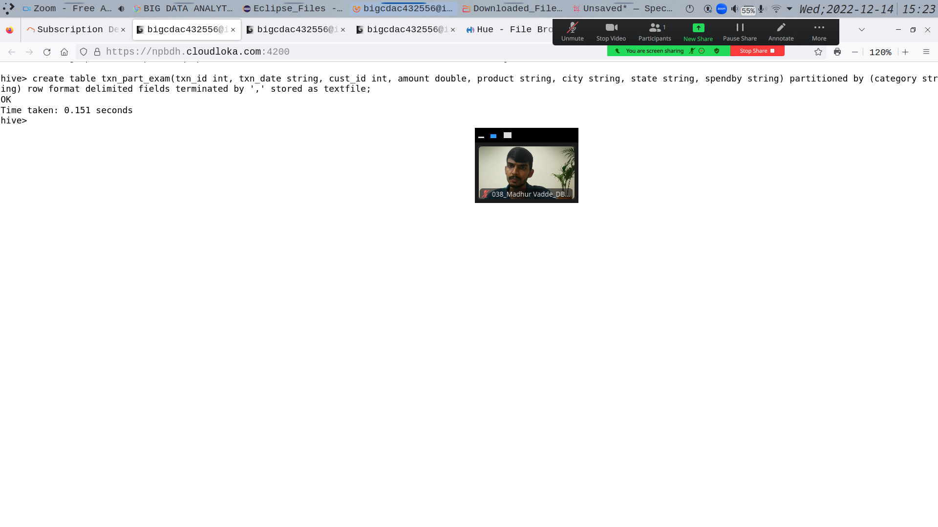

Q3)

>

from pyspark.sql.types import StructType, IntegerType, StringType, DoubleType, LongType

air_schema = StructType().add("year", StringType(), True).add("quarter", StringType(), True).add("avg_revenue_per_seat", DoubleType(), True).add("total_no_of_booked_seats", LongType(), True)

air_df = spark.read.format("csv").option("header","True").schema(air_schema).load("hdfs://nameservice1/user/bigcdac432556/airlines_exam.csv")

air_df.registerTempTable("airlines")

**Query 1:**

q1 = spark.sql("select year, sum(total_no_of_booked_seats) total_travelled from airlines group by year order by total_travelled desc limit 1")

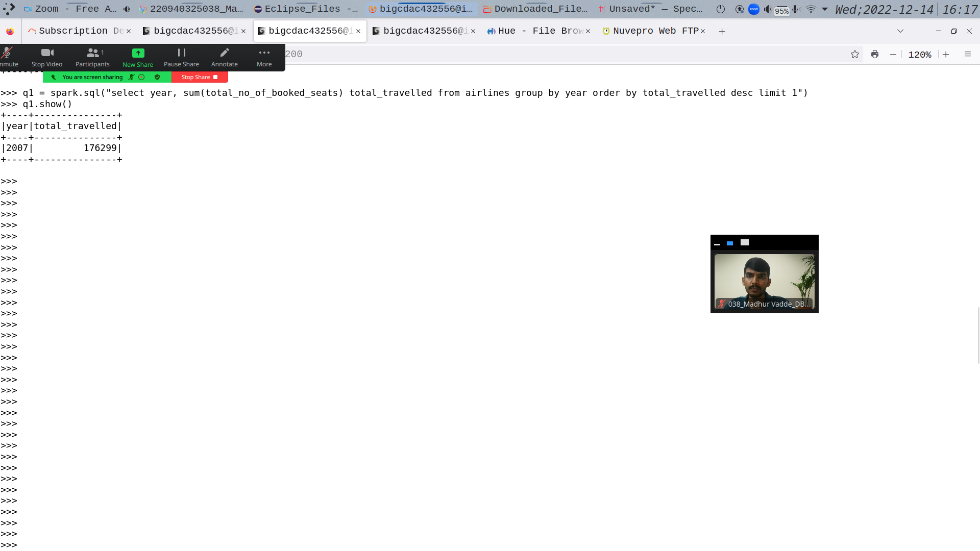

**Query 2:**

q2 = spark.sql("select year, (sum((avg_revenue_per_seat * total_no_of_booked_seats))/1000000) revenue_million from airlines group by year order by revenue_million desc limit

1")

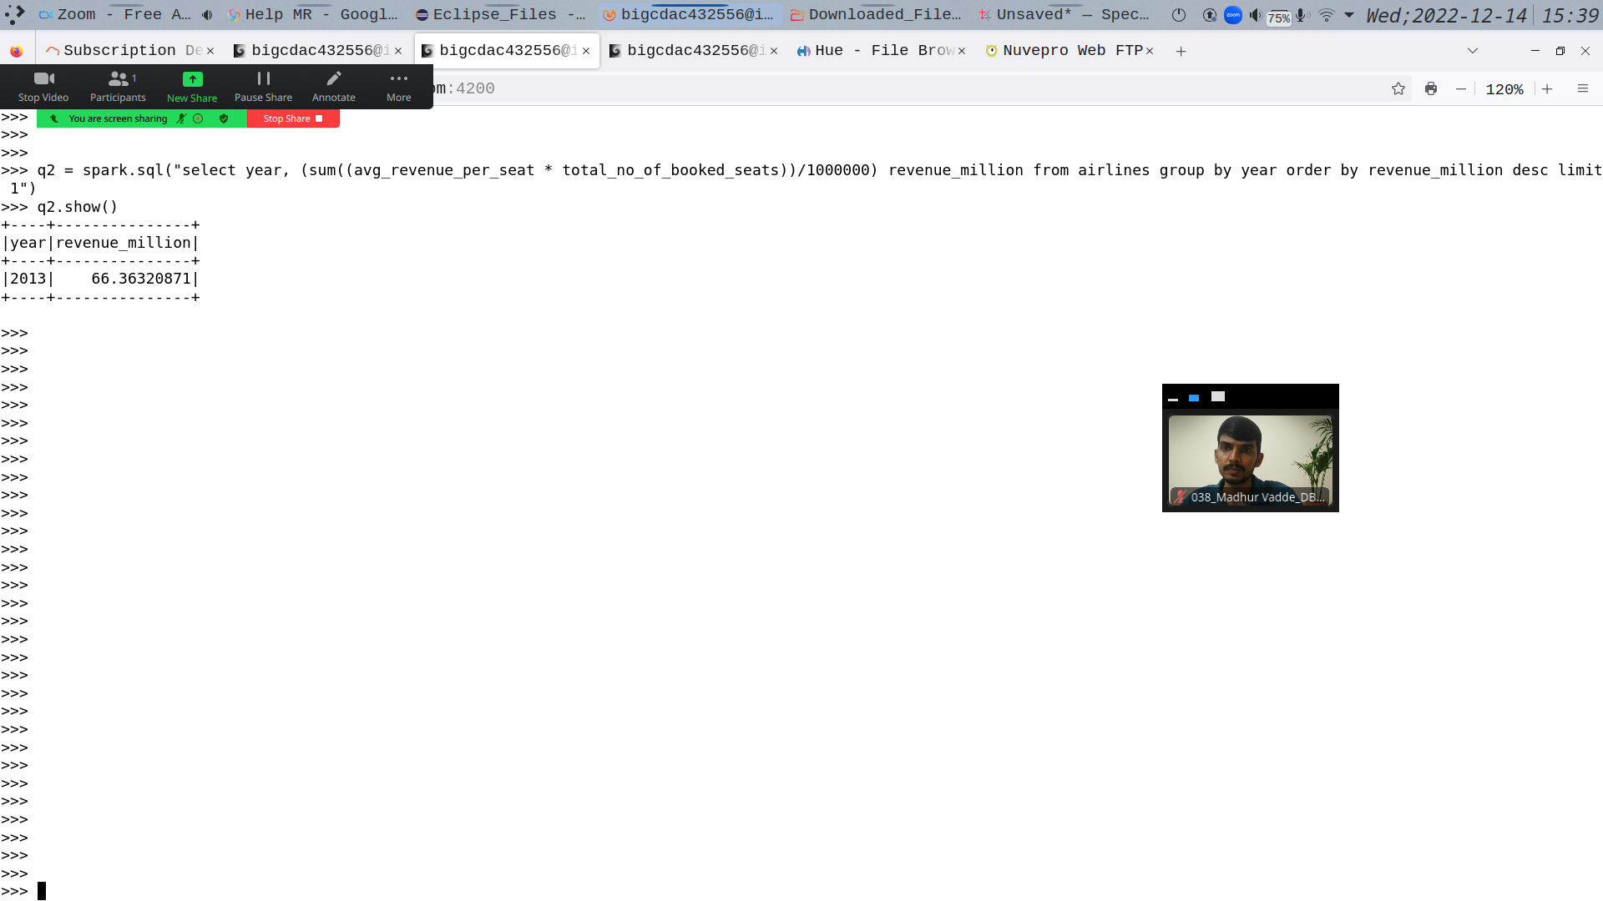

**Query 3:**

q3 = spark.sql("select year, quarter, ((avg_revenue_per_seat * total_no_of_booked_seats)/1000000) highest_revenue_million from airlines order by highest_revenue_million desc limit 1")

